Dampfross 2 – spezial rules & variants
Translation by T. Volbach (Gognatz@aol.com) – feel free to improve this ☺

Map: North Italy (Norditalien)

- The track between Domodossola (O 51) and hex R 50 already exists and doesn’t have to built any more.

- A track between E 42 and B 41 is allowed to be built through French territory (exception to the rule)

- Special Tours:

- Yugoslavia / Jugoslawien (Split or Trieste)
- Austria / Österreich (any hex in the plain)
- Switzerland / Schweiz (any hex in the plain or Domodossola)
- France / Frankreich (any hex in the plain)
- South Italy / Süditalien (Rome, Pescara, A 21 or A 23)
- Sardinia / Sardinien (roll the dice a second time: even – Sardinia, uneven – Corsica)

Map: South Italy (Süditalien)

- Special tours:

During the Operatin phase every 4th tour is a Special tour. The destination is determined by the roll of one dice:

- Sicilian / Sizilien
- Greece / Griechenland (there’s a special field for this purpose that has to be reached)
- Ischia or Capri (roll the dice a second time: even - Ischia, uneven Capri)
- 5/6 North Italy (Rome,L’Aquila or Pescara)

Map: Austria (Österreich)

- As an exception to the rule a track may be built across the broken line through Germany (Deutschland), Yugoslavia (Jugoslawien) or Italy (Italien). These are the tracks between C 11 and D 4, G 33 and F 29 or D 27, Salzburg (P 13) and K 7
In case there were no tracks built during building phase these tracks are running – they’re assumed to be built by the nation itself. In those cases fees have to be paid to the country you’re in, not to a player.

- Special tours:

1- West Austria / West-Österreich (Hex G 1)
2- Germany / Deutschland (I 1 to A 56)
3- Czech Republic / Tschecheslowakei (D 56 to H 76)
4- Hungary / Ungarn (L 36 to A 79)
5- Yugoslavia / Jugoslawien (A 22 to J 37)
6- Italy / Italien (C3 to A 20)

Map: Switzerland (Schweiz)

  - As an exception to the rule a track may be built across the broken line outside Switzerland (Schweiz). In case there were no tracks built during building phase these tracks are running – they’re assumed to be built by the nation itself. In those cases fees have to be paid to the country you’re in, not to a player.

  - Special tours:

- France / Frankreich
- France / Frankreich or Germany / Deutschland
- Germany / Deutschland
- Austria / Österreich and Liechtenstein

TREE FROG VARIANT

Using this variant tracks don’t necessarily have to be connected. During the game players may make up to 8 “jumps” – but not more than 2 by each player !
If a player wants to do such a “jump” he may use up to 3 hexes of another players track. For the turn-off a the other players track he certainly has to pay one unit.

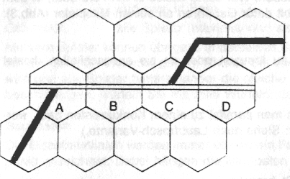
Picture:

If „black“ has connected to „white’s“ track he can branch off at B,C or D. Each use of “white’s” track certainly has to be paid.

